Falls quiz

Circle the answer you think is correct and get a score out of 10

What proportion of people aged 65 or older fall each year?

Falls quiz



1 in 2 1 in 3 1 in 10

What percentage of falls are due to the environment?



1 in 2 1 in 3 1 in 10

Hearing aids are available free on the NHS?

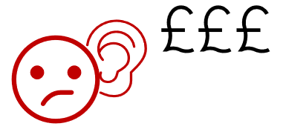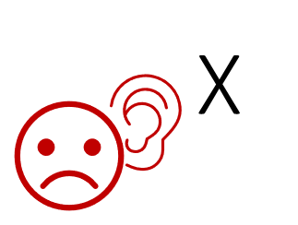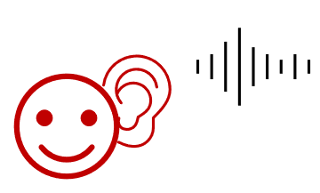

True False Up to a certain income threshold

People at risk of falls must not wear slippers.



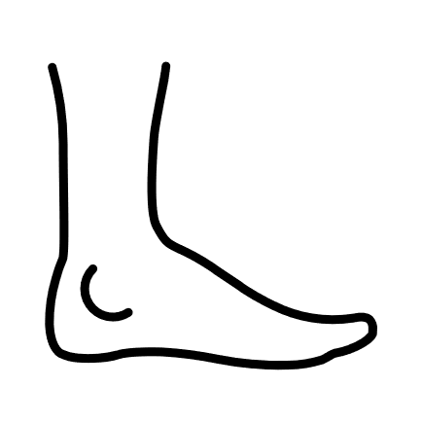

True False

Between ages of 50 and 70 we lose about 20% of our muscle strength.

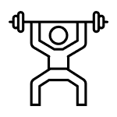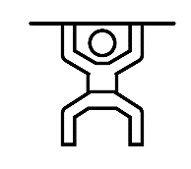

True False

You can do exercises to improve your strength without leaving your chair.



True False

It is advisable to have a regular medication review if you take multiple medications or take medicine for a long-term condition.

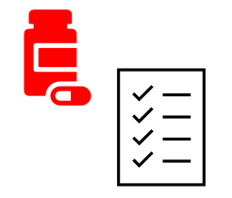

True False

As you get older, you don’t need to eat as much food.



True False

How many glasses of water/tea/coffee should a person drink every day?



1-2 glasses 4-5 glasses 7-8 glasses

You can reduce your risk of having a fall by making some easy changes.



True False

Score out of 10: /10

Falls Quiz –Answers

1. 1 in 3 . See <https://www.nhs.uk/conditions/falls/> for more information. In people aged over 80, it is 1 in 2 (half).
2. 1 in 3 (again!). <https://www.sciencedirect.com/science/article/abs/pii/S0749069018305159> These include slippery surfaces, badly lit rooms, worn carpets, staircases without hand rails, unsupportive or worn out furniture, badly designed bathrooms, clutter and pets underfoot.
3. True. See <https://www.nhs.uk/conditions/hearing-aids-and-implants/>
4. False. Slippers can be worn if they fasten up and have a good grip- avoid open backs!
5. False, we lose around 30% of our muscle strength between the ages of 50 and 70. <https://www.csp.org.uk/system/files/get_up_and_go_0.pdf> (page 7)
6. True. There are a number of simple exercises which can be done- but always go at your own pace and stay safe! <https://www.csp.org.uk/system/files/get_up_and_go_0.pdf> (page 16)
7. True. See <https://www.ageuk.org.uk/bp-assets/globalassets/waltham-forest/documents/advice-guides/medication-faq.pdf> to learn more
8. False. The best amount to eat varies between individual people and their own health- but it is always important to get a good balanced diet, including protein, vitamins and minerals. If you are unsure, speak to a GP or medical professional about what is right for you.
9. 7-8. See <https://www.nhs.uk/live-well/eat-well/food-guidelines-and-food-labels/water-drinks-nutrition/> to learn more. Remember that water, lower-fat milk and sugar-free drinks, like tea and coffee, all count.
10. True! There are lots of free resources to help you, including <https://www.csp.org.uk/system/files/get_up_and_go_0.pdf>