

**TOP TIPS: Reducing Your Risk of Falls**

(Please use the tick boxes where you think you need to take action.)

**Talk to your GP/health or social care professional:**

|  |
| --- |
| * If you experience a fall, loss of balance, dizziness or fainting. * To review your medication and ask about any side effects. * For advice about how to quit smoking (Smoking can weaken bones). * If your walking aid is in poor condition, unsuitable or the wrong height. * If you notice any changes in going to the toilet (frequency or urgency). |

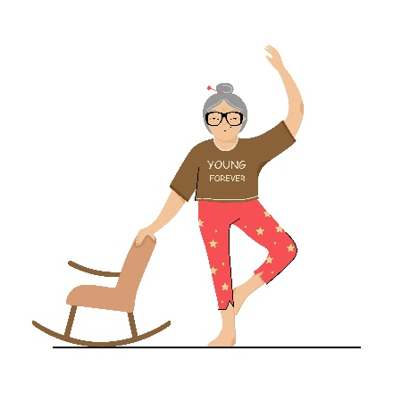**Looking after yourself:**

|  |
| --- |
| * Keep Active - Take regular activity and/or exercise to keep joints moving and strengthen muscles. * Have your eyesight and hearing checked annually. * Eat well-balanced, regular meals and increase your calcium and vitamin D intake by consuming foods high in calcium and getting regular sunlight. (Or ask your GP if supplements are an appropriate alternative for you) * Aim to drink 8 glasses of non alcoholic fluid a day unless you have been advised by GP/consultant to restrict fluid intake. |

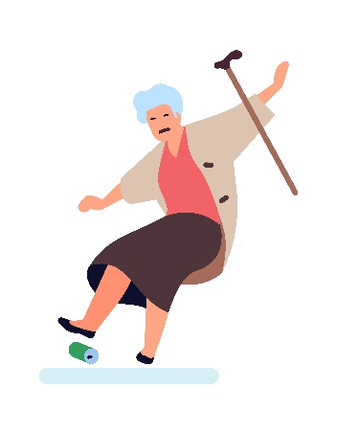**Consider your environment:**

|  |
| --- |
| * Ensure your home is well lit especially on the stairs and corridors; turn on a light when getting out of bed at night. Use high wattage light bulbs. * Keep items within easy reach to avoid climbing, bending or stretching. * Consider handrails on the stairs, at external doorways and the bathroom. * Keep the house warm, you will move more freely and be safer if you should fall. * Mop up spillages straight away to avoid slipping. * Remove trip hazards such as trailing wires, rugs, clutter. |

**Consider what you wear:**

|  |
| --- |
| * Ensure your shoes and slippers fit well, have an enclosed back with good tread. * Have your toe nails cut regularly. * Wear your glasses and hearing aid. * Avoid long trailing clothes. * Consider how you would summon help if you fall. E.g: wear a pendant alarm, keep your mobile phone on your person. |